1 Chedi
- Chedi Dynasty (Kalinga – Kharavela): Around 1st century BCE (short duration, ~30–40 years influence)
The Mahameghavahana dynasty (2nd/1st century BCE – early 4th century CE) was an ancient Indian ruling house of Kalinga (modern Odisha), established after the decline of the Mauryan Empire. Also known as the Chedi dynasty, its most prominent ruler was Kharavela, famous for the Hathigumpha inscription, which chronicles his military conquests, patronage of Jainism, and public welfare works.
Key details:
- Dynasty Names: Also referred to as Cheti or Chetavamsa, derived from the titles of its kings, notably "Mahameghavahana" (Lord of the Great Cloud).
- Capital: The capital was located in Kalinga, often associated with Suktimati-Puri.

The third king, who expanded the kingdom to include South Kosala and parts of the Andhra region.
- Significant Contributions:
  - Hathigumpha Inscription: A detailed, 17-line inscription on the Udayagiri hills near Bhubaneswar detailing Kharavela's 13-year reign.
  - Infrastructure: Extensive investment in irrigation, infrastructure, and public works.
  - Culture: Patronage of Jainism, though the reign was marked by religious tolerance.
  - Caves: Built the caves in Udayagiri and Khandagiri for Jain monks.
- Succession: Kharavela was succeeded by his son, Kudepasiri, according to Manchapuri cave inscriptions.
The dynasty is considered pivotal in restoring the political and cultural prominence of Kalinga after the devastation of the Kalinga War by Ashoka.
2
The Chedi Dynasty of Kalinga (Mahameghavahanas) ruled mainly in ancient Odisha (Kalinga region) during the post-Mauryan period.

📅 ⏳ Time Period
- 🟢 c. 1st century BCE to 1st century CE
- Peak period: around 1st century BCE (Kharavela’s reign)

👑 🏆 Important Kings & Chronology
1️⃣ Early rulers (founding phase)
- Founder line: Mahameghavahana dynasty
- Early rulers are less clearly known historically
- The dynasty established control in Kalinga after Mauryan decline

2️⃣ Most Important King – Kharavela
- 👑 Kharavela (3rd ruler of dynasty)
- 🕰️ Reign: approx. c. 1st century BCE (around 200–150 BCE debated in sources)
- 📍 Capital: Kalinganagara (near present Odisha region)
⭐ Key achievements:
- Restored Kalinga’s independence after Ashokan conquest
- Conducted multiple military campaigns
- Expanded influence across North, Central & South India (as per Hathigumpha inscription)
- Patron of Jainism
- Built public works (irrigation, infrastructure)

3️⃣ Later rulers
- After Kharavela, dynasty continued but:
  - Less historical evidence available
  - Political power gradually declined
- Eventually replaced by later regional powers (early Odisha dynasties)

📜 Main Source of Information
- 🪨 Hathigumpha Inscription (Udayagiri hills, Odisha)
  - Written in Prakrit (Brahmi script)
  - Gives details of Kharavela’s 13-year reign
  - Most reliable source for this dynasty

📊 Quick Timeline (Easy Revision)
- c. 1st century BCE → Rise of Mahameghavahana Chedis in Kalinga
- c. 1st century BCE (main phase) → Reign of Kharavela (golden period)
- 1st century CE onward → Decline of dynasty

📌 One-line summary
👉 The Chedi (Mahameghavahana) dynasty ruled Kalinga mainly in the 1st century BCE, reaching its peak under King Kharavela, known for military expansion, Jain patronage, and the Hathigumpha inscription.
🏛️ Last Ruler of Chedi (Mahameghavahana) Dynasty of Kalinga
👉 The last known ruler of the Chedi / Mahameghavahana dynasty is:
👑 Vakatadeva (also written as Vakradeva / Vakradeva II in some sources)

📌 Important points:
- He is considered the final identifiable king of the Mahameghavahana line.
- After him, the dynasty gradually declined due to:
  - Weak central control
  - Rise of new regional powers in Odisha
- Exact details of his reign are not well recorded in inscriptions.

⚠️ UPSC Note (Very Important):
- After Kharavela (peak ruler), the dynasty becomes fragmented and poorly documented.
- So historians often say:
👉 “Post-Kharavela rulers are obscure, and the last ruler is uncertain, but Vakatadeva is generally mentioned as the final known king.”

📊 One-line answer:
👉 The last known ruler of the Chedi (Mahameghavahana) dynasty was Vakatadeva, after whom the dynasty declined and faded from history.

3
🏛️ Chedi (Mahameghavahana) Dynasty of Kalinga – Rulers List (UPSC Notes)
The Mahameghavahana dynasty of Kalinga is also called the Chedi dynasty of Kalinga. Its rulers are not fully known, but some important names are recorded from inscriptions and traditions.

👑 Important Rulers of Chedi / Mahameghavahana Dynasty
1️⃣ Mahameghavahana
- Founder of the dynasty (eponymous ruler)
- Established Chedi rule in Kalinga
- Very limited historical details available

2️⃣ Aira (or Aila) Maharaja
- Early ruler mentioned in traditions/inscriptions
- Considered part of early dynastic line

3️⃣ Kharavela ⭐ (Most Important)
Kharavela
- 3rd ruler and greatest king
- 1st century BCE
- Famous for:
  - Military conquests
  - Jain patronage
  - Hathigumpha inscription
- Revived Kalinga’s power after Mauryan decline

4️⃣ Vakradeva (possible later ruler)
- Mentioned in later interpretations
- Considered a post-Kharavela ruler
- Very little reliable information

⚠️ Important Note for UPSC
- Only Kharavela is clearly documented
- Other rulers are:
  - Fragmentary
  - Based on inscriptions and tradition
- So, full ruler list is not completely confirmed historically

📌 Quick Revision Table
Order | Ruler | Importance
1 | Mahameghavahana | Founder
2 | Aira Maharaja | Early ruler
3 | Kharavela | Greatest ruler
4 | Vakradeva | Later/declining phase

🧠 One-line Summary
👉 The Chedi (Mahameghavahana) dynasty had Mahameghavahana as founder and Kharavela as its greatest ruler, while other rulers are less clearly known from historical records.

If you want, I can also make:
✔ MCQs for prelims practice
✔ Timeline chart of all Odisha dynasties
✔ Comparison: Mahameghavahana vs Satavahana dynasty

4
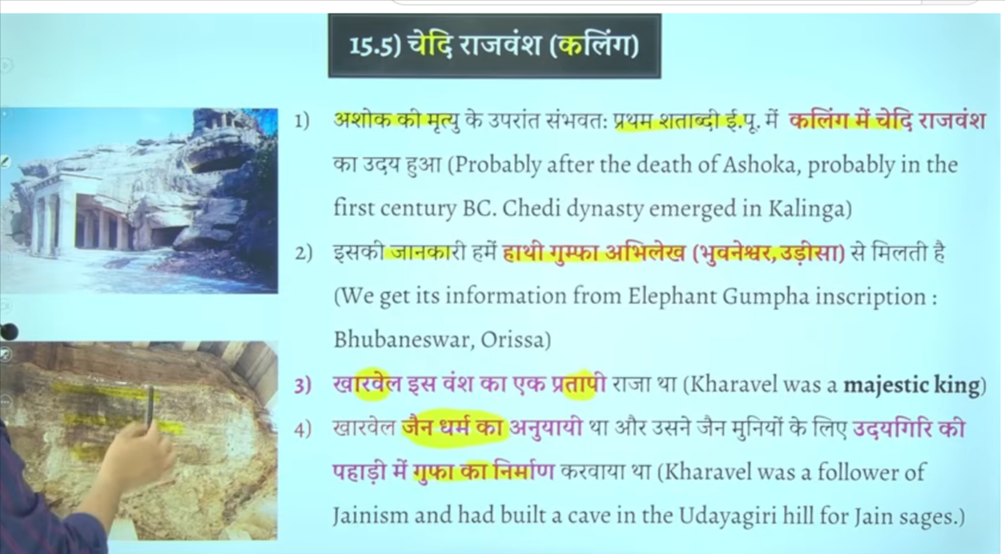

Ise tarah hai odhissa wale region me kalinga jise chedi rajvansh bhe kaha jata hai
Chedi vansh ka mahan raja tha kharvela
Kharvela ke hathigumfa abhelekh se hume bharatvarsha ka ullekh dekhne ko milta hai
Bharatvarsha ka first ulledkh dekhne ko milta hai
Means first time bharvarsha ke bat keg ae the is inscription me

Ek udaygiri ke Pahadi Madhya pradsh me bhe is the hai
But yaha jo hum udyagiri ke bat kar rahe hai wo odhissa me hai

Kharveli chedi vansh ke raja the jinhone hathigufa inscription ka ankaan karwaya tha
Use hathi gumfa abhileksh se hume kharvela ke jankarimilte hai kaling ke jankari milte hai
Use kharvela se hume ye jankari milte hai ki jo kharvela the wo chedi vansh ke mahan raja the jain dharm ke anuyaaee the aur jain sadhuon ke lyie inhone udaygiri ki gufaon me shailashrya ka Nirman karwaya tha

5 Kharavela of Kalinga

The Hathigumpha inscription is a 17-line, 1st-century BCE rock inscription in Prakrit (Brahmi script) located in the Udayagiri caves near Bhubaneswar, Odisha. It is the primary source of information on the Kalinga ruler Kharavela, documenting his 13-year reign, military victories, public welfare works, and patronage of Jainism.
Testbook +4
Key Details for UPSC:
- Location & Description: Found in Udayagiri Caves, Odisha. It is a 17-line inscription on the overhanging brow of the cave (Hathigumpha = Elephant Cave).
- Ruler: King Kharavela of the Chedi/Mahameghavahana dynasty of Kalinga.
- Language & Script:
Prakrit language and Brahmi script.
- Key Contents:
  - Military Campaigns: Mentions campaigns against Magadha (defeating king Bahasatimita), Satavahana ruler Satakarni I, and bringing back the idol of Kalinga Jina from Magadha.
  - Public Works: Records repairing a canal originally built by the Nanda dynasty (about 300 years prior) and constructing various public structures.
  - Religious Patronage: Highlights Kharavela as a staunch follower of Jainism.
  - Military Exploits: Details his 13 years of rule and various military achievements.
- Significance: It is the earliest epigraphic evidence using the term "Bharatvarsha".
Testbook +7
Important Distinctions:
- The inscription was first discovered by A. Sterling in 1820 and decoded by James Prinsep.
- It is not in Sanskrit, it is in Prakrit, unlike the later Junagarh inscription which is in Sanskrit.

📍 1. Introduction
Kharavela was the most powerful ruler of the Mahameghavahana (Chedi) dynasty of Kalinga.
- Time period: c. 1st century BCE
- Capital: Kalinganagara (Odisha region)
- Known from: Hathigumpha Inscription

🏛️ 2. Dynasty Background
- Dynasty: Mahameghavahana / Chedi dynasty of Kalinga
- Region: Kalinga
- Post-Mauryan rise of regional power
- Kharavela = 3rd ruler and most famous king

⚔️ 3. Military Achievements (Very Important)
- Restored independence of Kalinga
- Conducted multiple military campaigns
- Claimed victories over:
  - Magadhan territories
  - Satavahana regions
  - Various northern and southern kings (as per inscription)
- Strengthened Kalinga as a regional power

📜 4. Hathigumpha Inscription (Key Source)
- Located at Udayagiri hills, Odisha
- Language: Prakrit
- Script: Brahmi
- Records:
  - 13 years of Kharavela’s reign
  - Military victories
  - Public works
  - Religious patronage
👉 Most important source for Kalinga history

🛕 5. Religion & Policy
- Patron of Jainism
- Supported Jain monks and establishments
- Followed religious tolerance (no persecution of other religions)

🚰 6. Administration & Public Works
- Strong and organized monarchy
- Major focus on:
  - Irrigation projects
  - Canal restoration (originally built by Nandas)
  - Public welfare infrastructure
- Promoted prosperity through state investment

🚢 7. Economy & Trade
- Boosted agriculture via irrigation
- Developed maritime trade
- Trade links with:
  - Sri Lanka
  - Southeast Asia (Myanmar, Thailand, Malaysia, Indonesia)
- Kalinga became a major eastern trade hub

🎨 8. Cultural Importance
- Associated with Udayagiri-Khandagiri cave architecture
- Hathigumpha inscription is a major example of early historical writing
- Promoted Jain cultural activities

📌 9. UPSC Key Points (Quick Revision)
- 1st century BCE ruler of Kalinga
- Famous for Hathigumpha inscription
- Strong military expansion
- Jain patron
- Restored Kalinga’s power after Mauryan decline
- Important for early Odisha history

🧠 One-line Summary
👉 Kharavela was the greatest ruler of ancient Kalinga who revived its political power, promoted Jainism, and is best known through the Hathigumpha inscription.

6 hathigumfa inscription
hathigumfa inscritpion and udaygiri ke pahadi both are same
No — Hathigumpha inscription and Udayagiri hills are NOT the same thing, but they are closely related.

🪨📍 1. Udayagiri Hills
Udayagiri Hills, Odisha
- A rock-cut cave complex in Odisha (near Bhubaneswar)
- Famous for:
  - Jain caves
  - Sculptures
  - Ancient rock-cut architecture
- Built mainly during Kharavela period

🪨📜 2. Hathigumpha Inscription
Hathigumpha Inscription
- A rock inscription carved inside Udayagiri hills caves
- Located specifically in Hathigumpha (Elephant Cave)
- Written in Prakrit language + Brahmi script
- Gives detailed history of Kharavela’s reign

🔗 3. Relationship between both
👉 Udayagiri Hills = location (site)
👉 Hathigumpha inscription = writing carved on the cave wall inside it

🧠 Simple analogy:
- Udayagiri Hills = 📍 “book shelf / place”
- Hathigumpha inscription = 📖 “book written on that shelf”

📌 UPSC Key Point:
✔ They are not same, but
✔ Hathigumpha inscription is located in Udayagiri caves

🧠 One-line answer:
👉 Udayagiri is the site (caves/hills), while Hathigumpha is the inscription carved inside one of its caves.

If you want, I can also show:
✔ Map of Udayagiri–Khandagiri caves
✔ Summary of all inscriptions of ancient India
✔ MCQs for revision 👍
udaygiri and hathigumfa relatec upsc quesiton do
Here are UPSC-style MCQs on Udayagiri and Hathigumpha Inscription:

🧠 MCQ 1
Consider the following statements:
- Hathigumpha inscription is located in the Udayagiri caves of Odisha.
- It is written in Sanskrit language using Brahmi script.
- It is associated with King Kharavela.
Which of the statements given above is/are correct?
A) 1 and 2 only
B) 1 and 3 only
C) 2 and 3 only
D) 1, 2 and 3
✅ Answer: B) 1 and 3 only

🧠 MCQ 2
Udayagiri and Khandagiri caves are best known for:
A) Buddhist rock-cut architecture of Mauryan period
B) Jain rock-cut caves associated with Kharavela
C) Gupta temple architecture
D) Ashokan edicts
✅ Answer: B) Jain rock-cut caves associated with Kharavela

🧠 MCQ 3
With reference to Hathigumpha inscription, consider the following:
- It provides information about military campaigns of Kharavela.
- It is written in Prakrit language.
- It is found in Udayagiri hills of Odisha.
Which is correct?
A) 1 and 2 only
B) 2 and 3 only
C) 1, 2 and 3
D) 1 and 3 only
✅ Answer: C) 1, 2 and 3

🧠 MCQ 4
Which of the following statements is correct?
A) Udayagiri is the name of an inscription
B) Hathigumpha is the name of a cave inside Udayagiri hills
C) Hathigumpha inscription is a primary source for Kharavela’s reign
D) Both are unrelated
✅ Answer: C) Hathigumpha inscription is a primary source for Kharavela’s reign

📌 Quick Revision:
- 🏞️ Udayagiri = cave complex (site)
- 🪨 Hathigumpha = inscription inside cave
- 👑 Linked to King Kharavela
- 🕉️ Jain association

If you want, I can make:
✔ 20 MCQs (Prelims level test)
✔ PYQ-based questions
✔ One-page revision sheet for Ancient Odisha 👍
what is the time iod of hathgumfa inscitpon
🪨📜 Time period of Hathigumpha Inscription
Hathigumpha Inscription dates to the:
📅 2nd century BCE (most accepted dating)
- Generally placed in c. 2nd century BCE
- Specifically linked to the reign of Kharavela
- His reign is usually dated around:
👉 c. 1st century BCE (some sources slightly differ)

📌 Why there is slight confusion?
- Inscription itself does not give an exact year
- Scholars estimate based on:
  - Language (Prakrit)
  - Script (early Brahmi)
  - Historical references in text

🧠 UPSC takeaway:
👉 Hathigumpha inscription belongs to late Mauryan / post-Mauryan period, mainly around
2nd–1st century BCE

🧾 One-line answer:
👉 The Hathigumpha inscription is dated broadly to the 2nd century BCE and is associated with King Kharavela of the 1st century BCE.

If you want, I can also give:
✔ Trick to remember ancient inscriptions chronology
✔ MCQs on inscriptions of India
✔ Difference between Ashokan inscriptions vs Hathigumpha 👍

Mahameghavahana or Chedi Dynasty of Kalinga
- In Kalinga (south Orissa), Mahameghavahana Chedis established a kingdom towards the end of the first century BC.
- The title speaks of the rulers’ power. The epithet Mahameghavahana means the ‘Lord of the Great Cloud’ who uses clouds as his vehicle.
  - It may mean that the kings were as powerful as Indra.
About Kharavela of Kalinga
- Kharavela was the third and greatest emperor of the Mahameghavahana dynasty of Kalinga.
- During Kharavela’s reign, the Chedi dynasty of Kalinga ascended to eminence and restored Kalinga’s lost power and glory, which had been subdued since the devastating war with Asoka.
- Kharavela might reinstate the Kalinga military. Within ten years, He could achieve a series of brilliant victories, extending his suzerainty from the Northwest part of India to the farthest extent in the south.
- Under Kaharavela’s generalship, the Kalinga state had a formidable maritime reach with trade routes linking it to the then Sri Lanka, Burma, Thailand, Vietnam, Kamboja, Malaysia, Bali, Sumatra and Jabadwipa.
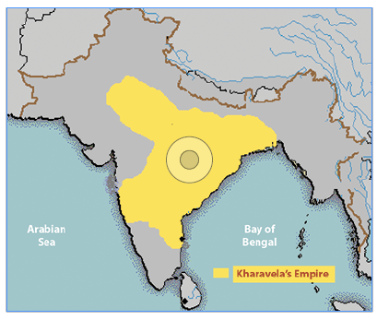
Administration of Chedi Dynasty of Kalinga
- The rise of a regular monarchy in Orissa under the Mahameghavahana dynasty marks the expansion of state polity into new regions.
- This development represented a significant evolution from previous political structures and added to the complexity of regional politics, especially as it posed challenges to the Magadh rulers.
- Kharvela’s administration is noted for its military and administrative skills, which contributed to the consolidation of Kalinga as a significant regional power.
Religion of Chedi Dynasty of Kalinga
- Kharvela was a notable patron of Jainism, actively supporting Jain monks and contributing to the construction of Jain temples and monuments.
- However, his administration was inclusive and did not discriminate against other religions, reflecting a policy of religious tolerance and harmony.
- This approach helped maintain social cohesion and stability within the diverse religious landscape of his kingdom.
Society of Chedi Dynasty of Kalinga
- Kharvela’s reign brought notable advancements in infrastructure, including the enlargement of an irrigation canal initially constructed by a Nanda king, which profoundly impacted agriculture and local prosperity.
- His substantial expenditures on the welfare of his subjects, including public works and social projects, reflected a commitment to improving living conditions and supporting the community.
- This benevolent governance contributed to the stability and growth of his kingdom.
Economy of Chedi Dynasty of Kalinga
- During the Mauryan rule, Kalinga was largely in a pre-state phase, characterised by rudimentary economic structures.
- The independent state under Kharvela saw significant economic development, including advances in infrastructure such as irrigation.
- This period marked an acceleration in economic activities, including trade and agriculture, driven by Kharvela’s initiatives and investments in public works.
Importance of Chedi Dynasty of Kalinga
- Kharavela inscribed the Hathigumpha inscription (elephant cave inscription) from Udayagiri in the 2nd Century BCE.
- Hanthigumpha inscription on Udaygiri hills near Bhuvaneshwar gives a detailed account of Kharvela’s military conquests.
- The inscription records the historical events of the reign in chronological order. It sheds light on political episodes and Kalinga’s religious, cultural, and social conditions during that glorious period.
- It is presented in Kavya style, using Prakrit as the language and Brahmi script, which is very similar to Pali.
- The Hatigumpha Inscription is like the history of Kharavela as a king, a conqueror, a patron of culture and a champion of Jainism.
- The accounts are corroborated by other historical evidence relating to contemporary times.
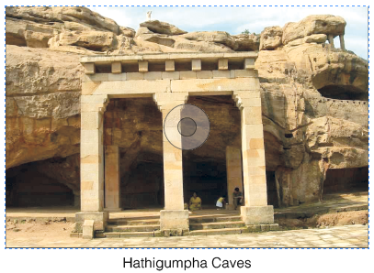
Satvahanas Dynasty (1st Century BCE – Early 3rd Century AD)
- The Satavahanas, also known as the Andhras, were among the most prominent dynasties in early Indian history, ruling from around the 1st century BCE to the 3rd century CE.
- Their empire spanned across the Deccan region, covering parts of modern-day Maharashtra, Andhra Pradesh, Karnataka, and Madhya Pradesh.
- The Satavahanas were crucial in bridging the cultural and political gap between North and South India.
- They are well-known for their contributions to trade, art, and architecture, fostering economic prosperity through extensive trade routes that connected India with the Roman Empire.
- The dynasty is also credited with simultaneously promoting Buddhism and Brahmanism, reflecting their policy of religious tolerance.
Read our detailed article on the Satavahanas Dynasty.
Conclusion
The post Mauryan period saw the rise of several regional dynasties, such as the Shungas, Kanvas, Satavahanas, and the Chedis of Kalinga, each contributing to India’s political and cultural development. These rulers promoted various religions, including Hinduism, Jainism, and Buddhism, while fostering trade and advancing art and architecture. This era set the stage for the Gupta dynasty, leaving a lasting impact on Indian civilization.

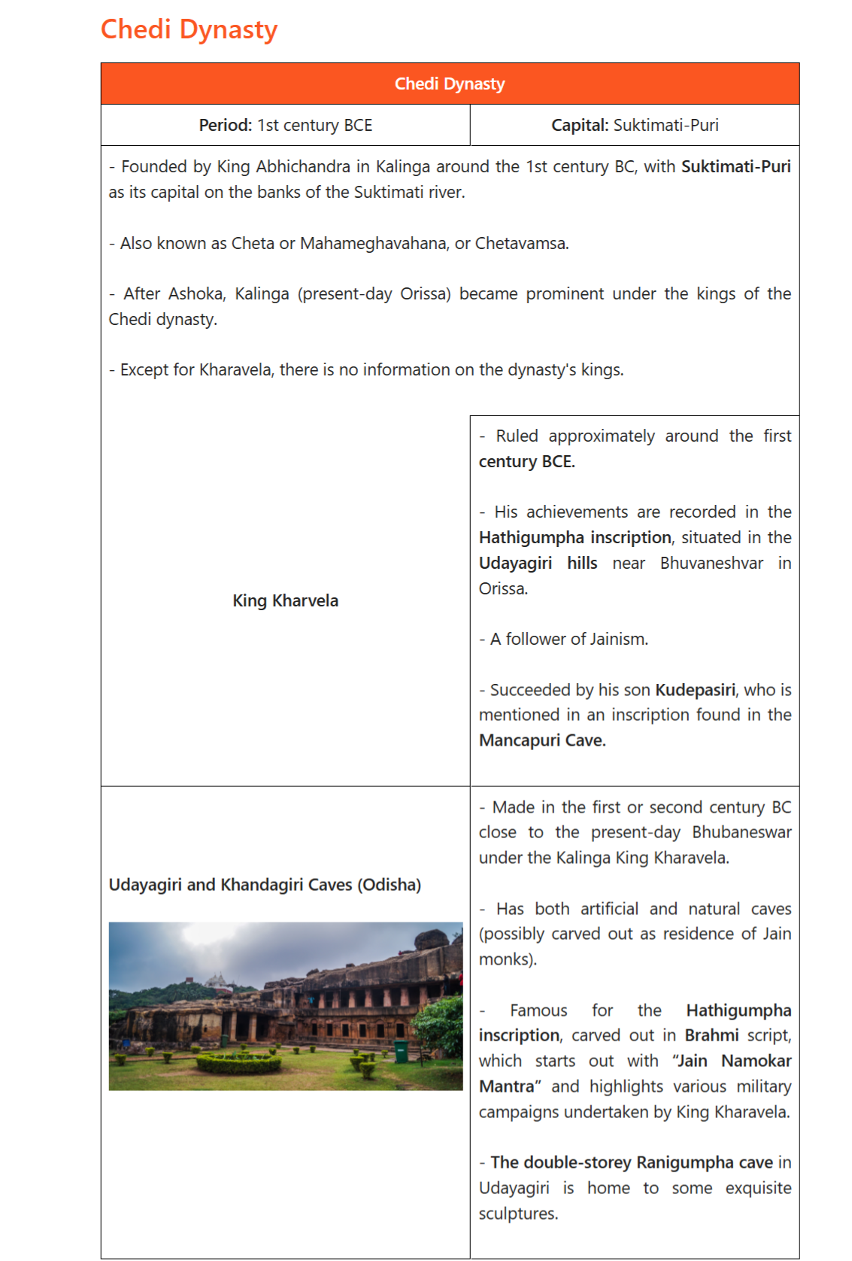

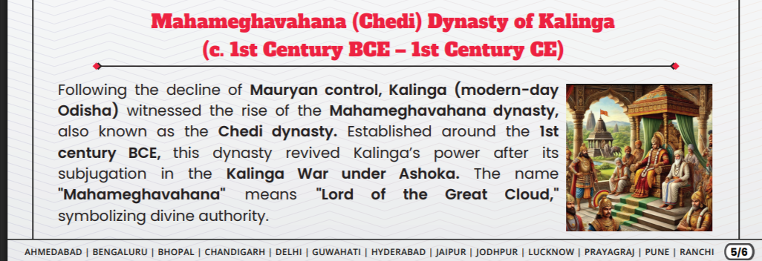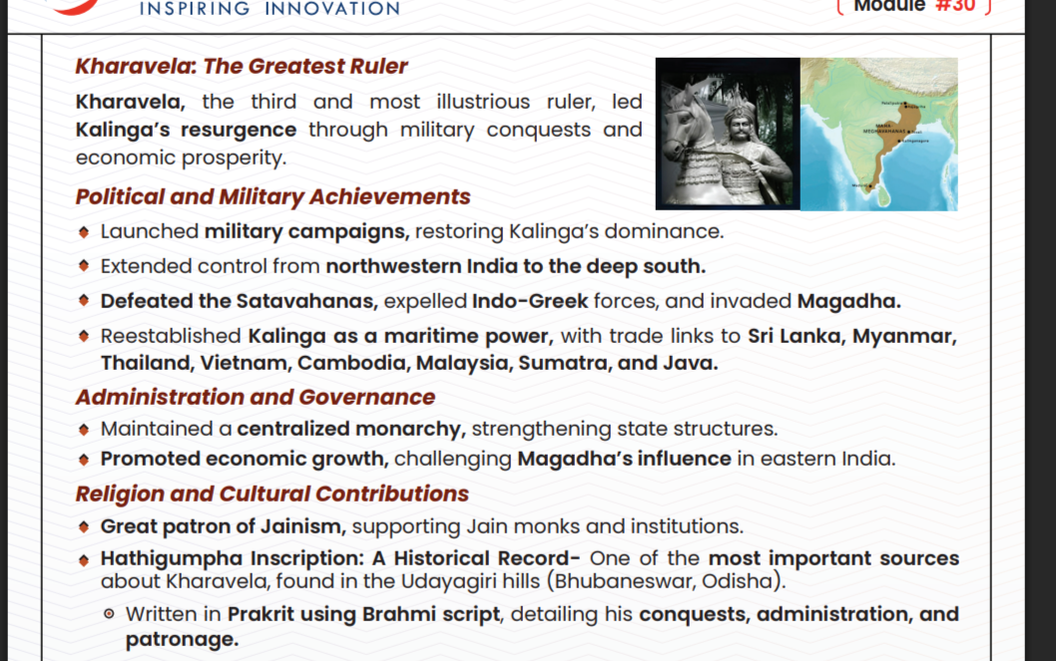
The Chedi Dynasty (c. 1st century BCE) was a powerful ruling house in Kalinga (modern Odisha), established by Mahameghavahana, whose most notable ruler was Kharavela. Known as the Mahameghavahana dynasty, they ruled after the Mauryan decline, with their history primarily derived from the Hathigumpha inscription in Bhubaneswar.
Next IAS +4
Key Aspects of the Chedi Dynasty
- Kharavela's Rule: The third and greatest ruler, King Kharavela, significantly expanded the kingdom and is celebrated in the Hathigumpha inscription.
- Infrastructure & Economy: Kharavela’s reign saw significant infrastructural advancements, including the improvement of irrigation canals and public works, boosting the region's prosperity
.
- Religion: The rulers, particularly Kharavela, patronized Jainism, though they maintained a policy of religious tolerance.
- Military Campaigns: Kharavela led successful military campaigns against surrounding kingdoms, including the Satavahana dynasty, restoring Kalinga's glory.
- Distinct from Mythical Chedi: This Kalinga-based dynasty is historically distinct from the earlier, semi-mythical Chedi kingdom of the Mahabharata era, which was located in central India (Bundelkhand) and ruled by Shishupala.
Wikipedia +5
The dynasty is generally considered to have been a powerful regional power during the post-Mauryan period, with a legacy tied closely to the cultural and military development of ancient Odisha.

Information regarding the total number of kings in the Chedi (or Mahameghavahana) dynasty of Kalinga is limited, as the primary source of history for this dynasty is the partially damaged Hathigumpha inscription.
Testbook
- Known Kings: While the dynasty ruled from the 1st century BCE, historical records primarily focus on King Kharavela.
- Genealogy: King Kharavela is identified as the third ruler of the Mahameghavahana/Chedi dynasty, succeeding his father.
- Successor: The Hathigumpha inscription suggests that Kharavela was succeeded by his son, Kudepasiri.
- Dynasty Scope: The Chedi dynasty, also known as Cheta or Chetavamsa, was based in Kalinga (modern-day Odisha).
Vajiram & Ravi +1
Note: While there are various mythological kings associated with the Chedi kingdom (e.g., Shishupala, Uparichara Vasu) mentioned in the Mahabharata, historical evidence specifically regarding the Chedi/Mahameghavahana dynasty of Kalinga in the post-Mauryan period is limited to only a few rulers

Here’s a clear, exam-ready summary of the Chedi (Cheta / Mahameghavahana) Dynasty in Kalinga 👇

🏛️ Chedi Dynasty (Kalinga) – Quick Notes
📍 Time & Region
- Period: 1st century BCE (Post-Mauryan period)
- Region: Kalinga (modern-day Odisha)
- Emerged after the decline of the Mauryan Empire

👑 Founder
- Traditionally attributed to King Abhichandra (as per some sources like coaching material)
- Dynasty also called:
  - Cheta / Chetavamsa
  - Mahameghavahana dynasty

⭐ Most Important Ruler: King Kharavela
- 3rd ruler of the dynasty
- Main source: Hathigumpha Inscription (Udayagiri Hills, near Bhubaneswar)
🔹 Achievements
- Expanded his kingdom through military campaigns
- Invaded regions in North and South India
- Promoted public works:
  - Built canals and irrigation systems
- Patron of art and architecture
🕉️ Religion
- Follower of Jainism
- Supported Jain monks and institutions

🏙️ Capital
- Suktimati / Puri region (exact identification debated by historians)

⚔️ Significance
- Major regional power in Post-Mauryan India
- Represents revival of Kalinga after Ashoka’s conquest
- Important for understanding:
  - Regional kingdoms
  - Early inscriptional history
  - Spread of Jainism

📜 Important Source
- Hathigumpha Inscription
  - Written in Prakrit (Brahmi script)
  - Provides a year-by-year account of Kharavela’s rule

⚠️ Exam Trap (Very Important)
Do NOT confuse:
- Chedi Dynasty (Kalinga, ancient, 1st century BCE)
❌ with
- Kalachuris of Chedi (medieval, Bundelkhand region)

🧠 One-line Revision
👉 Chedi (Mahameghavahana) dynasty of Kalinga rose in the 1st century BCE; its greatest ruler Kharavela is known from the Hathigumpha inscription and was a patron of Jainism.

If you want, I can convert this into MCQs, notes, or a revision chart for UPSC 👍
what is frangment dyansyt ya region
You’re probably asking about “fragmented dynasty / fragmented regions” (not “frangment dyansyt”)—a common UPSC concept.

📌 What is a Fragmented Region / Fragmentation?
Fragmentation means a large empire breaks into many smaller independent kingdoms or dynasties.

🏛️ In History (UPSC Context)
After the decline of a big empire (like the Mauryan Empire), India did not remain under one ruler. Instead:
➡️ Many regional powers emerged
➡️ Political unity broke
➡️ This period is called Political Fragmentation

🔎 Example
After Mauryan decline (2nd century BCE):
- Chedi (Kharavela) – Kalinga
- Shungas – North India
- Satavahanas – Deccan
- Indo-Greeks – North-West
👉 All these ruled separately, not as one empire

🧠 Simple Definition
👉 Fragmented region = Area divided into many small kingdoms instead of one big empire

⚡ One-line for UPSC
👉 Political fragmentation refers to the breakdown of a centralized empire into multiple regional states.

If you meant something else (like a specific dynasty name), tell me 👍

